Cross-field haptics:Multiple direction haptics combined with magnetic and electrostatic fields

【Summary】：

We present a new method of rendering haptic textures that utilizes electrostatic and magnetic ﬁelds. In con-ventional research, a single physical quantity is used to render haptic textures. Although these ﬁelds have no direct interference, combining them provides beneﬁts such as the ability to produce multi-resolution haptic images and synergistic effects on haptic perception.

【Equipment principle】：

The proposed system physically deforms and changes the physical force between the ﬁnger and device. To achieve this, we combine magnetic and electrostatic ﬁelds. We use ferroﬂuid [8], which is a ﬂexible liquid used in a magnetic ﬁeld, and electrovibration [9] with adsorption force used in an electrostatic ﬁeld to develop this device.

【Related fields】:

【Magnetic Field】

【Electrostatic Field】

【Acoustic Field】

【Cross-Field Haptics】

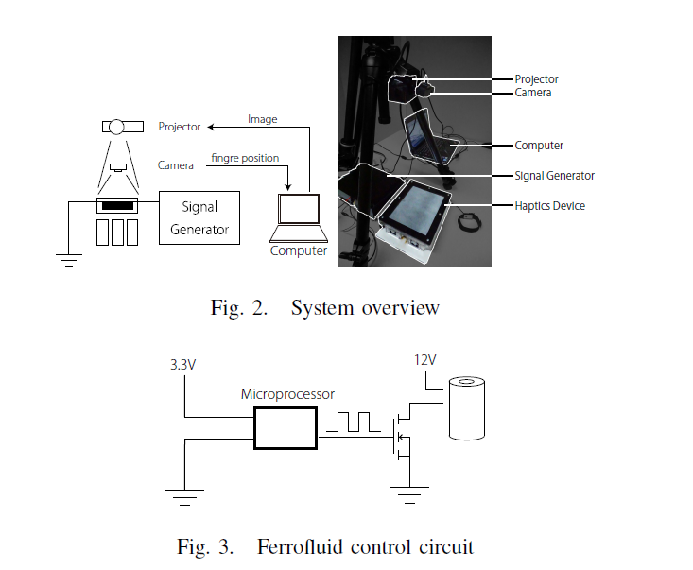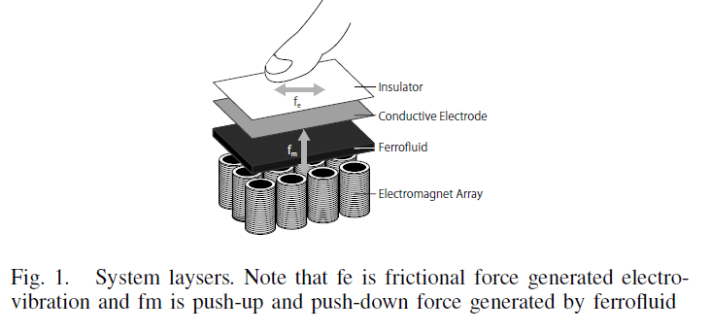

【Device implementation】：

1. **Proposed System** Our device consists of an electromagnet array layer, a ferroﬂuid layer, and a conductive electrode layer (Fig. 1).
2. Electromagnet array layer: Ferroﬂuid was controlled using an electromagnet.
3. Ferroﬂuid layer: Ferroﬂuid, which appears as a black ﬂuid, is a liquid whose viscosity changes in response to a magnetic ﬁeld. Ferroﬂuids are prepared by dissolving nanoscale ferromagnetic particles in a solvent such as water or oil and remain strongly magnetic even in a ﬂuid condition. That ferroﬂuids form spikes along magnetic ﬁeld lines when the magnetic surface force exceeds the stabilizing effects of the ﬂuid weight and surface tension is well known. If a magnetic ﬁeld is provided the viscosity is linearly controllable using a magnetic ﬁeld. In this study, we focused on the upward force of ferroﬂuid. When viscosity changes, the force pushing up a ﬁnger by vibration is generated by switching the magnetic ﬁeld in the electromagnet.
4. Conductive electrode layer: Electrovibration [4] uses a conductive electrode. Electrovibration provides haptic feed-back using electrostatic adhesion. Furthermore, it provides high-voltage electric vibration to the electrode. When a body is connected to ground and a ﬁnger moves on the electrode, force is generated. Force is generated in the direction in witch a movement is resisted. Therefore, a frictional force is generated.
5. **Control**

Arduino DUE and a personal computer were used for controlling a circuit. A ﬁnger witch a marker attached is tracked with a camera, and the tracking position is used as input. A projector sends the image to a device based according to location of the tracked ﬁnger. An electronic signal is sent both to the electromagnet and to the electrode having a signal generator based on a tracked coordinate (Fig. 2).

(Note: In our device, the electric and magnetic fields do not affect each other. We can consider and control each haptic feedback individually. The magnetic field generated by the electrostatic field depends only on the current flowing in the electrodes. Electrical vibrations require only a few mA Current, so the resulting magnetic field becomes very small.)

【Applications】:

1. **Texture Rendering**:

An application that expresses various textures is possible (Fig. 8(a)). To realize this, we changed the frequency of the signal which add to electrode and frequency of the signal which add to electromagnet. The study in [4] expressed texture using friction; our application expresses texture using the force of ferroﬂuid in addition to friction.

1. **Drag & Drop**:

Assisting GUI operation is possible by using the Push-Pull haptics such as drag & drop, which is a basic GUI operation. Using electrovibration our application produced friction when dragging ﬁles, icons and other similar items. A tactile illusion is created that is similar to that experienced in the real world. When objects arrive at a destination, we change the degree of stickiness of the ferroﬂuid. The user can determine whether the object has arrived at its destination by the hardness of the surface. This can be a useful guide for operation, and the moving speed the to the destination increases.

1. **Body Tissue Simulation**:

Cross-ﬁeld haptics can mimic the body tissue such as the heart and liver (Fig. 8(b)). In surgical operations, accurate operation to match the state of the body tissue is essential. The behavior can be matched easily if the speciﬁc organ can be expressed. To reproduce organs in virtual space, the texture of the organ surface, viscosity such as softness, and deformations such as pulsation must be expressed. Surface texture can be expressed using electrovibration, and viscosity and deformation can be expressed using the ferroﬂuid.

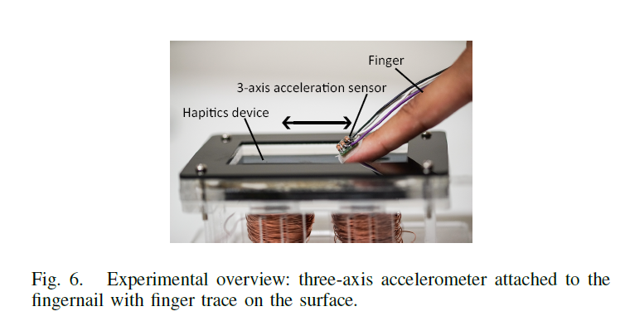 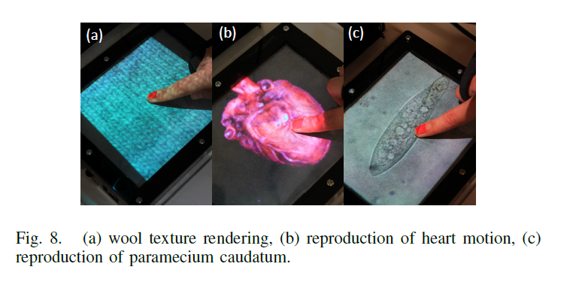

【Equipment evaluation】：

Quantitative evaluation

(Finger vibration interacts with no haptics, only with magnetic fields, only with electrostatic fields, and a combination of magnetic and electrostatic fields.)

【Important Reference】:

[1] K. Minamizawa, D. Prattichizzo, and S. Tachi, “Simpliﬁed design of haptic display by extending one-point kinesthetic feedback to multipoint tactile feedback,” in 2010 IEEE Haptics Symposium, March 2010, pp. 257–260.

[2] M. Weiss, C. Wacharamanotham, S. Voelker, and J. Borchers, “Fingerﬂux: Near-surface haptic feedback on tabletops,” ser. UIST ’11. New York, NY, USA: ACM, 2011, pp. 615–620. [Online]. Available: http://doi.acm.org/10.1145/2047196.2047277

[3] Y. Jansen, T. Karrer, and J. Borchers, “Mudpad: Tactile feedback and haptic texture overlay for touch surfaces,” ser. ITS ’10. New York, NY, USA: ACM, 2010, pp. 11–14. [Online]. Available: http://doi.acm.org/10.1145/1936652.1936655

[4] O. Bau, I. Poupyrev, A. Israr, and C. Harrison, “Teslatouch: Electrovibration for touch surfaces,” ser. UIST ’10. New York, NY, USA: ACM, 2010, pp. 283–292. [Online]. Available: http://doi.acm.org/10.1145/1866029.1866074

[5] Y. Monnai, K. Hasegawa, M. Fujiwara, K. Yoshino, S. Inoue, and H. Shinoda, “Haptomime: Mid-air haptic interaction with a ﬂoating virtual screen,” ser. UIST ’14. New York, NY, USA: ACM, 2014, pp. 663–667. [Online]. Available: http://doi.acm.org/10.1145/2642918.2647407

[6] K. J. Kuchenbecker, J. Fiene, and G. Niemeyer, “Improving contact realism through event-based haptic feedback,” IEEE Transactions on Visualization and Computer Graphics, vol. 12, no. 2, pp. 219–230, Mar. 2006. [Online]. Available: http://dx.doi.org/10.1109/TVCG.2006.32

[7] K. J. Kuchenbecker, J. Romano, and W. McMahan, Haptography: Capturing and Recreating the Rich Feel of Real Surfaces. Berlin, Heidelberg: Springer Berlin Heidelberg, 2011, pp. 245–260. [Online]. Available: http://dx.doi.org/10.1007/978-3-642-19457-3 15

[10] H. Ando, T. Miki, M. Inami, and T. Maeda, “Smartﬁnger: Nail-mounted tactile display,” ser. SIGGRAPH ’02. New York, NY, USA: ACM, 2002, pp. 78–78. [Online]. Available: http://doi.acm.org/10.1145/1242073.1242113

[11] M. Amberg, F. Giraud, B. Semail, P. Olivo, G. Casiez, and N. Roussel, “Stimtac: A tactile input device with programmable friction,” ser. UIST ’11 Adjunct. New York, NY, USA: ACM, 2011, pp. 7–8.[Online]. Available: http://doi.acm.org/10.1145/2046396.2046401

[12] G. Casiez, N. Roussel, R. Vanbelleghem, and F. Giraud, “Surfpad: Riding towards targets on a squeeze ﬁlm effect,” ser. CHI ’11. New York, NY, USA: ACM, 2011, pp. 2491–2500. [Online]. Available: http://doi.acm.org/10.1145/1978942.1979307

[17] O. Bau, U. Petrevski, and W. Mackay, “Bubblewrap: A textile-based electromagnetic haptic display,” ser. CHI EA ’09. New York, NY, USA: ACM, 2009, pp. 3607–3612. [Online]. Available: http://doi.acm.org/10.1145/1520340.1520542

[18] J. T. K. V. Koh, K. Karunanayaka, and R. Nakatsu, Linetic: Technical, Usability and Aesthetic Implications of a Ferroﬂuid-Based Organic User Interface. Berlin, Heidelberg: Springer Berlin Heidelberg, 2013, pp. 180–195. [Online]. Available: http://dx.doi.org/10.1007/978-

3- 642-40477-1 11

[27] K.-U. Kyung and J.-Y. Lee, “wubi-pen: Windows graphical user interface interacting with haptic feedback stylus,” ser. SIGGRAPH ’08. New York, NY, USA: ACM, 2008, pp. 42:1–42:4. [Online]. Available: http://doi.acm.org/10.1145/1401615.1401657